Equilibrium analysis

Spawner and yield per recruit at equilibrium are commonly used to estimate biological reference points. They are obtained from selection-, natural mortality- and weight-at-age data.

If all individuals die at age n then

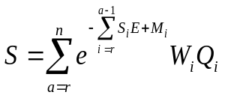

If n is a plus group (i.e. summation of all ages from the last age to infinity) then

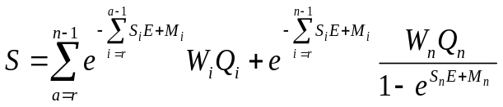

where

n is oldest age
is age at recruitment
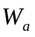 is weight at age in the catch
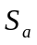 is selectivity at age
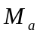 is natural mortality at age
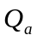 is natural mortality at age
E is overall F i.e. the F multiplier

If all individuals die at age n then

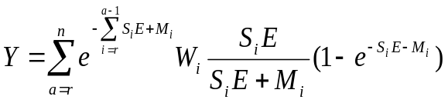

If n is a plus group (i.e. summation of all ages from the last age to infinity) then

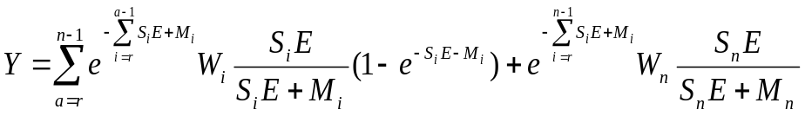

The consequences of changes in growth, recruitment, density dependence sexual maturation and discarding are explored by combining the equilibrium curves with the stock-recruitment relationship.

The spawning stock biomass is expressed as a function of the spawner per recruit ratio by rearranging the stock recruit model.
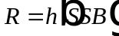
i.e.
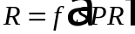

the expected recruitment can then given as a function of F using spawner per recruit as a function of fishing mortality.
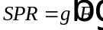

Yield is likewise given by YPR×R, where
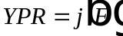

The maximum of this function is the maximum sustainable yield (MSY) and the corresponding values of fishing mortality and SSB- F_{MSY} and SSB_{MSY} respectively.

